# 7-3 Project Two Submission

# CS 255 System Design Document

## UML Diagrams

### UML Use Case Diagram

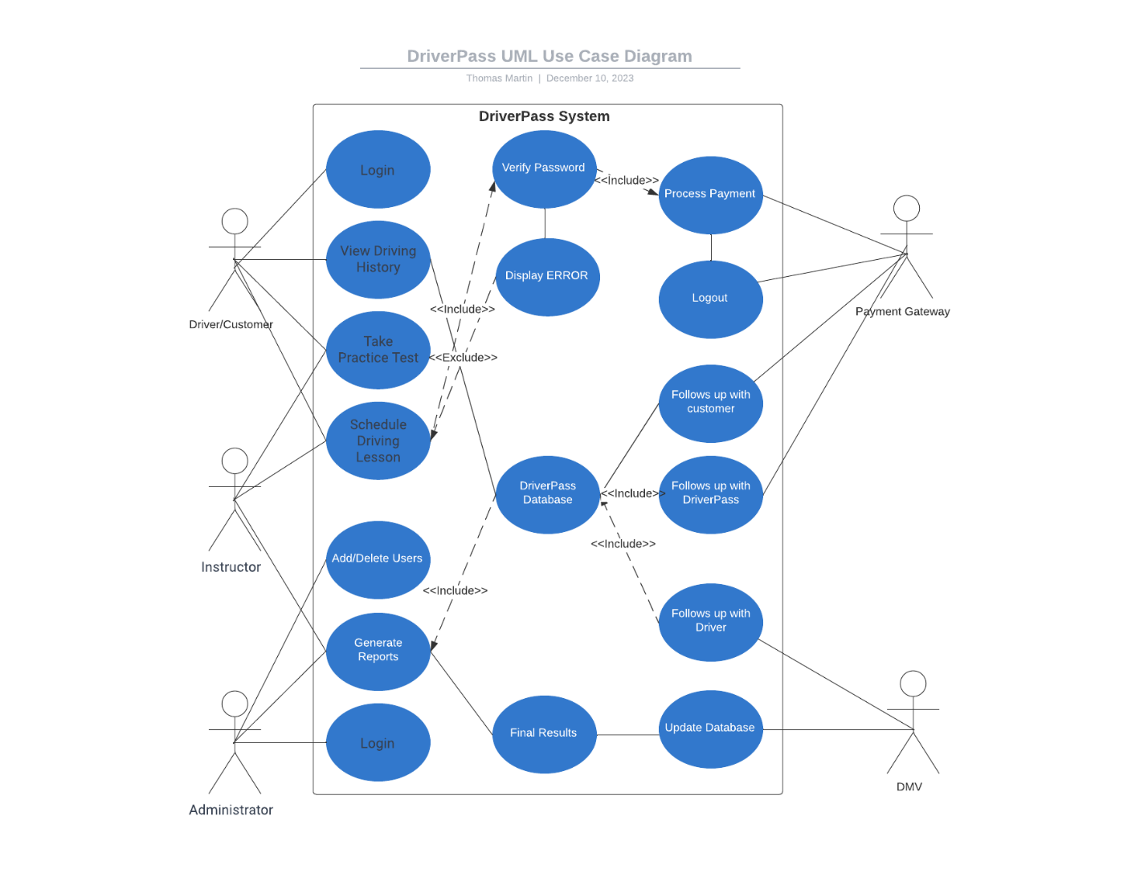

### UML Activity Diagrams

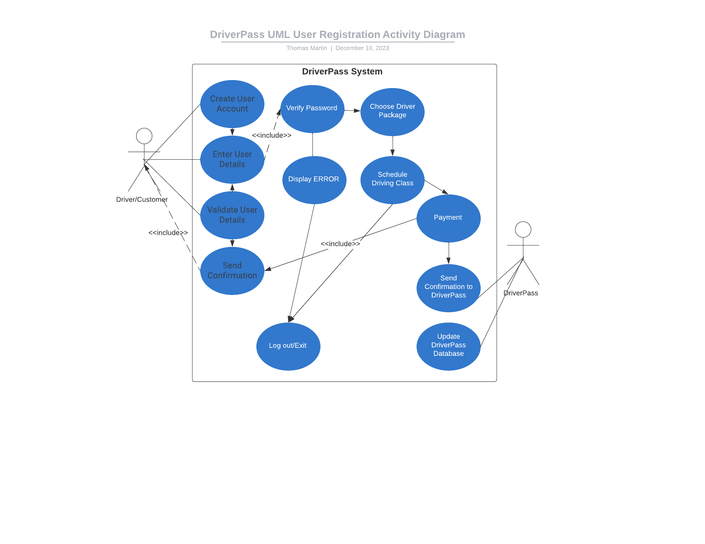

### UML Sequence Diagram

### UML Class Diagram

## Technical Requirements

Based on the functional and non-functional requirements for the DriverPass system, the technical requirements would start with:

Hardware Requirements:

Server - infrastructure to host the web-based application and database.

Web-based systems - should be accessible from various devices such as desktops, laptops, tablets, and smartphones.

Load balancers - should efficiently distribute incoming traffic among multiple servers to prevent overloading.

Software Requirements:

The choice of the operating system for web and database servers shall align with system compatibility and security considerations.

The DBMS should support data integrity, security features, and efficient query processing.

The system shall be developed using a suitable web application

Development Tools:

Backend Development tools and languages like Python, or Java could be used for server-side programming.

Frontend Development like HTML, CSS, and JavaScript along with libraries or frameworks.

Infrastructure Requirements:

The system shall leverage cloud-based infrastructure to ensure scalability, flexibility, and efficient resource utilization.

Regular data backups and a recovery plan to protect against data loss.

System Maintenance and Updates:

A version control system, such as Git, shall be used for managing code changes, tracking revisions, and coordinating collaborative development efforts.